Lecture # 24:

Objective:

* REGULAR EXPRESSON

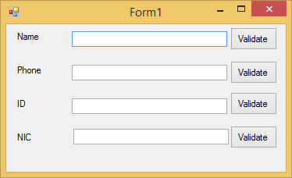

using System;

using System.Collections.Generic; using System.ComponentModel; using System.Data;

using System.Drawing; using System.Linq; using System.Text;

using System.Windows.Forms;

using System.Text.RegularExpressions;

namespace Regularexpression

{

public partial class Form1 : Form

{

public Form1()

{

InitializeComponent();

}

private void btnname_Click(object sender, EventArgs e)

{

if (Regex.IsMatch(textname.Text, @"^[a-z ]+$"))

{

MessageBox.Show("valid");

}

else

{

MessageBox.Show("Invalid");

}

}

private void btnphone_Click(object sender, EventArgs e)

{

if (Regex.IsMatch(textphon.Text, @"\b\d\d\d\d-

\d\d\d\d\d\d\d"))

{

MessageBox.Show("valid");

}

else

{

MessageBox.Show("Invalid");

}

}

private void btnid_Click(object sender, EventArgs e)

{

if (Regex.IsMatch(textid.Text, @"^[0-9]+$"))

{

MessageBox.Show("valid");

}

else

{

MessageBox.Show("Invalid");

}

}

private void btnnic_Click(object sender, EventArgs e)

{

if (Regex.IsMatch(textNic.Text, @"\b\d\d\d\d\d-

\d\d\d\d\d\d\d\d-\d"))

{

MessageBox.Show("valid");

}

else

{

MessageBox.Show("Invalid");

}

}

}

}